

POWER BI PROJECT PRESENTATION

Hello everyone,

Your Power BI project presentation is mandatory and will be treated as a final evaluation (interview-level assessment).

You are required to submit a self-recorded video presentation explaining your project end-to-end.

⚠️ RULES
- 🎥 Camera ON throughout the presentation
- 🖥️ Screen sharing (Power BI Desktop)
- ⏱️ Duration: Exactly 15 minutes
- 🗣️ Speak in your own words (no reading allowed)

🎥 RECORDING INSTRUCTIONS
- Prepare full flow before recording
- Use a well-lit environment
- Ensure clear audio (no background noise)
- Maintain professional posture
- Do not pause or edit excessively

⏱️ 0:00 – 1:00 → INTRODUCTION TO PROJECT
You should:
- Introduce yourself
- Mention selected project clearly
- Briefly describe what your project is about

Focus on:
- Type of project
- Purpose of the project

⏱️ 1:00 – 2:30 → DATASET & DATA SOURCE EXPLANATION
You should explain:
- Dataset used in your project
- Source of the data (Kaggle, open data, provided dataset, etc.)
- Number of rows, columns, and fields

Focus on:
- What each column/field represents
- Why you chose this dataset

Important:
- Don’t just mention the file name
- Explain the structure and relevance clearly

⏱️ 2:30 – 4:00 → DATA CLEANING & TRANSFORMATION (POWER QUERY)
You should explain:
- Steps taken in Power Query to clean the data
- Columns removed, renamed, or transformed
- Data type corrections made

Focus on:
- Why each transformation was necessary
- How it improved data quality

Important:
- Explain the logic behind each Power Query step

⏱️ 4:00 – 6:00 → DATA MODEL & RELATIONSHIPS
You should explain:
- Tables in your data model
- Relationships between tables (one-to-many, etc.)
- Star schema or flat table used

Focus on:
- How relationships enable cross-filtering
- Why the model is structured this way

⏱️ 6:00 – 9:00 → DAX MEASURES (QUESTION → MEASURE → INSIGHT)
You should explain each measure:
- What business question are you trying to answer
- How you used DAX to calculate it
- What result/insight it provides

Focus on:
- Purpose of each DAX measure
- Business value of the measure

Important:
- Don’t only show the DAX formula
- Explain the reasoning and logic behind it

⏱️ 9:00 – 12:00 → DASHBOARD / REPORT WALKTHROUGH
You should:
- Walk through each page of your Power BI report
- Explain the visuals used (bar chart, line chart, card, slicer, etc.)

Focus on:
- Why you chose each visual type
- How slicers and filters interact with the visuals
- Story your dashboard tells

Important:
- Explain step-by-step logic
- Demonstrate interactivity (click on a slicer, cross-filter, etc.)

⏱️ 12:00 – 14:00 → FINAL INSIGHTS / ANALYSIS
You should explain:
- Key insights discovered from your dashboard

Focus on:
- Patterns and trends visible in the visuals
- Important findings from the data

Important:
- Explain why insights matter in a real-world business context

⏱️ 14:00 – 15:00 → CONCLUSION + THANK YOU
You should explain:
- What you learned from this project
- Challenges faced (data issues, DAX logic, visualization choices)
- Improvements possible

End with:
- “Thank you”

IMPORTANT EXPECTATIONS
You must clearly explain:
- Dataset and data source
- Data cleaning steps in Power Query
- Data model and relationships
- DAX measures and logic
- Dashboard design and insights

📌 POWER BI PROJECT REQUIREMENTS
Ensure your project includes:
- Dataset sourced from a reliable source (Kaggle, open data portal, etc.)
- Data import and Power Query transformation
- Data model with relationships (where applicable)
- DAX measures (calculated columns and measures)
- Multiple report pages with a variety of visuals
- KPI cards, charts, slicers, and filters
- Drill-through or tooltips (if applicable)
- Solving real-world business problem statements

📊 PPT STRUCTURE (MINIMUM 15 SLIDES)
- Title Slide (Project name, your details)
- Introduction
- Why This Project
- Dataset Information & Source
- Data Cleaning Steps (Power Query)
- Data Model & Relationships
- DAX Measures Overview
- Problem Statement
- Dashboard Page 1 – Overview
- Dashboard Page 2 – Detailed Analysis ( add more Pages if needed )
- Key Visuals Explanation
- Insights (Business Understanding)
- Conclusion (Include Insights Summary, Recommendations, and Challenges Faced)

AVOID
- Reading from screen ❌
- Only showing DAX formulas without explanation ❌
- Memorized speech ❌
- Weak explanation of visuals ❌

EVALUATION CRITERIA
You will be judged on:
- Understanding of Power BI concepts
- Clarity of explanation
- Logical thinking in dashboard design
- Depth of explanation of DAX and data model

FINAL ADVICE
Don’t think: “I must follow every line exactly”

Think: “I must clearly explain my Power BI project like I am talking to an interviewer”

Use Screen record in PPT app

OR

Use ScreenRec :-

Steps to Download ScreenRec application
Link: https://screenrec.com/screen-recorder/

Step1: Download the application as usual, do not select any other option

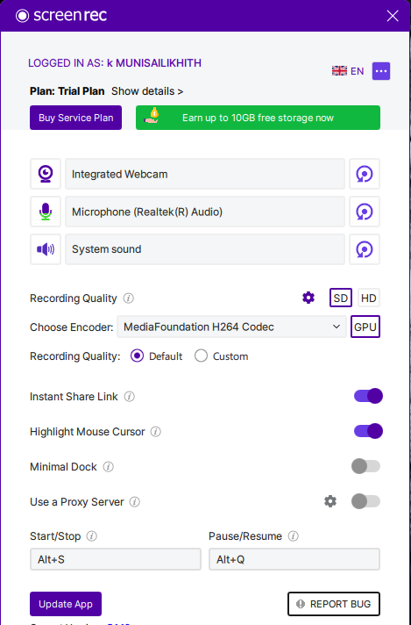

Step2: Try to Start recording with the Application with the above selected options,
Keep it it SD Mode
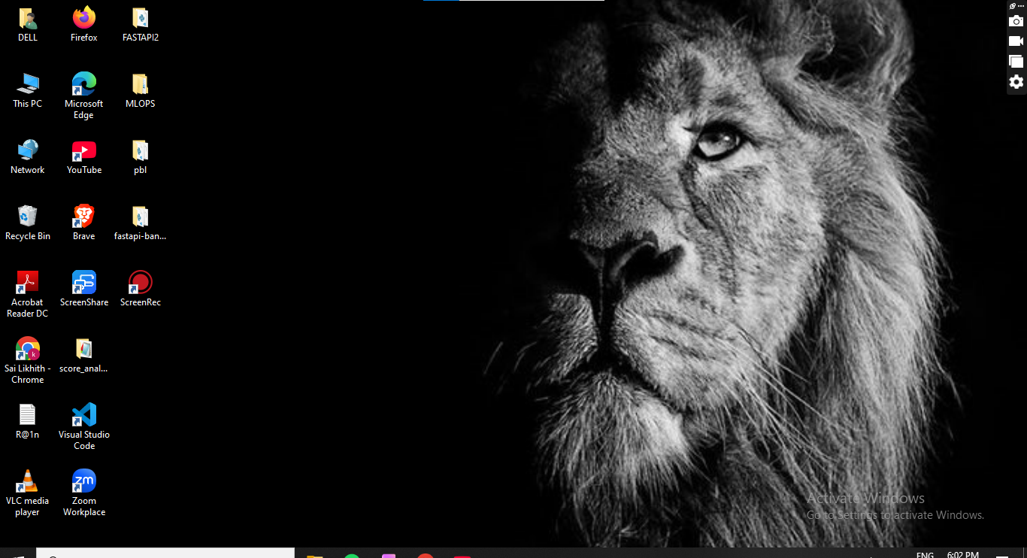

Step3: Once it start Recording you will get option to drag the size you need to record make to drag full page
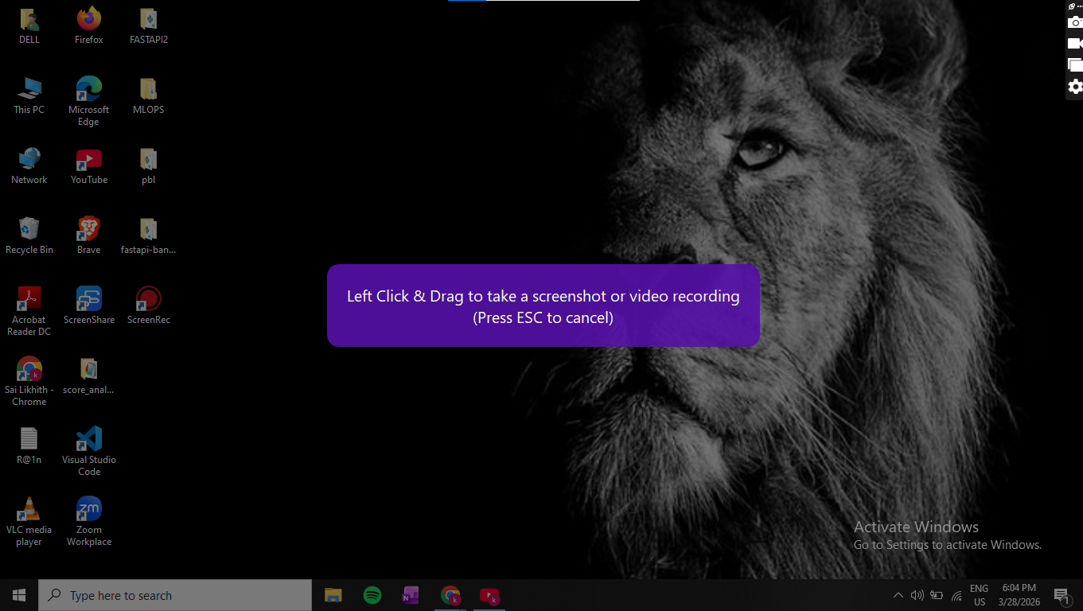
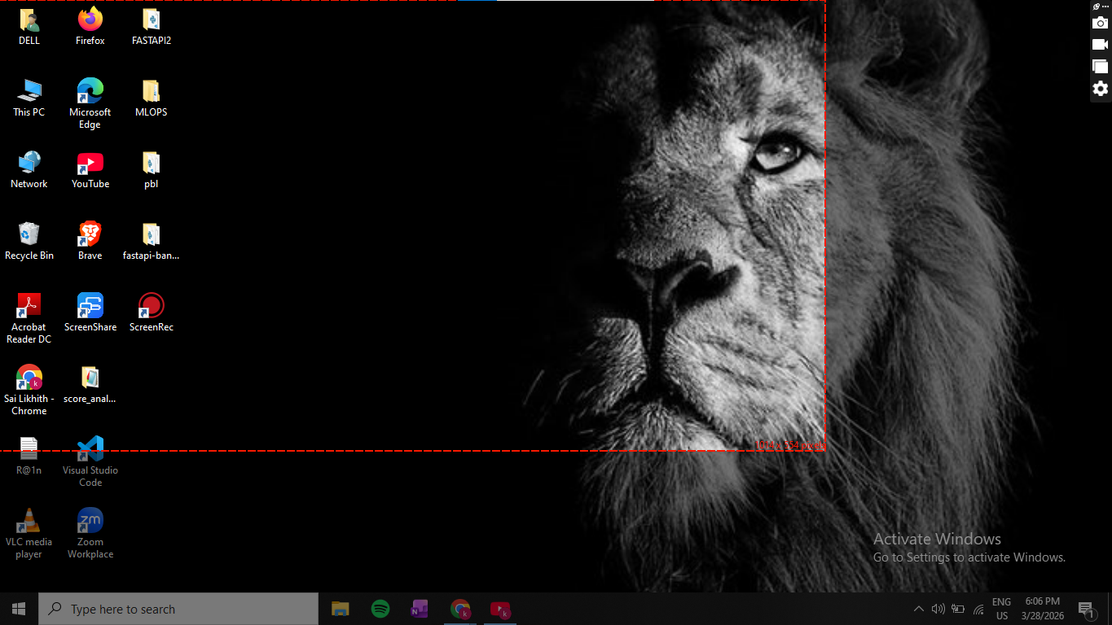

Like this drag from left top Corner to Right bottom corner

Step4:

Make sure you Record Yourself and check the position of yourself while recording
You will get , 3 different cutouts make sure you select the small circle
Record This Presentation in a well Lit Condition and having proper Voice Clarity


Step5:
Once Recording is complete, Pause and Record and Press the Yellow button to save the recording That’s it.
Step6:
Once everything is done make sure that recording is done in a proper above mentioned Format.

